Submitted By

Student Name: Vedanti Kingri

05 SQL and Python Analysis Requirements
SQL Tasks

05 SQL and Python Analysis Requirements

Minimum SQL Tasks
Step 1: Create Database & Step 2: Create Tables
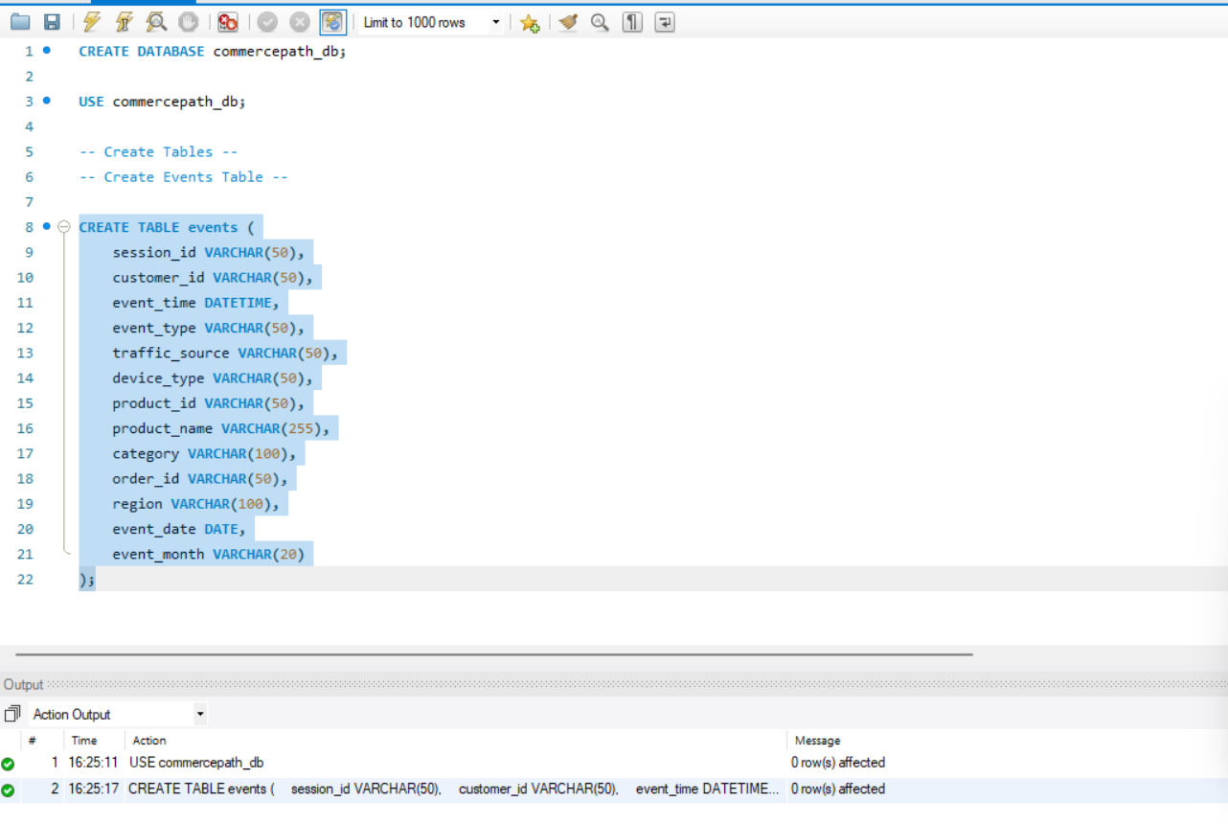

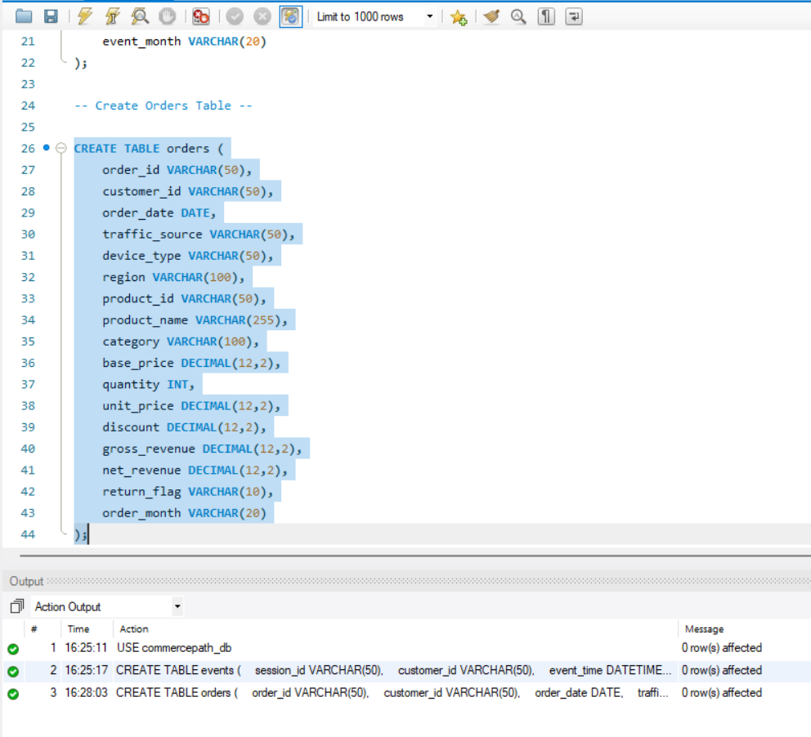

Step 3: Import Excel Data into MySQL
MySQL Workbench does not directly import Excel easily.
First convert sheets to CSV
In Excel:
- Open Cleaned_Events.
- Go to File → Save As.
- Select: CSV UTF-8 (Comma delimited)
- Save as
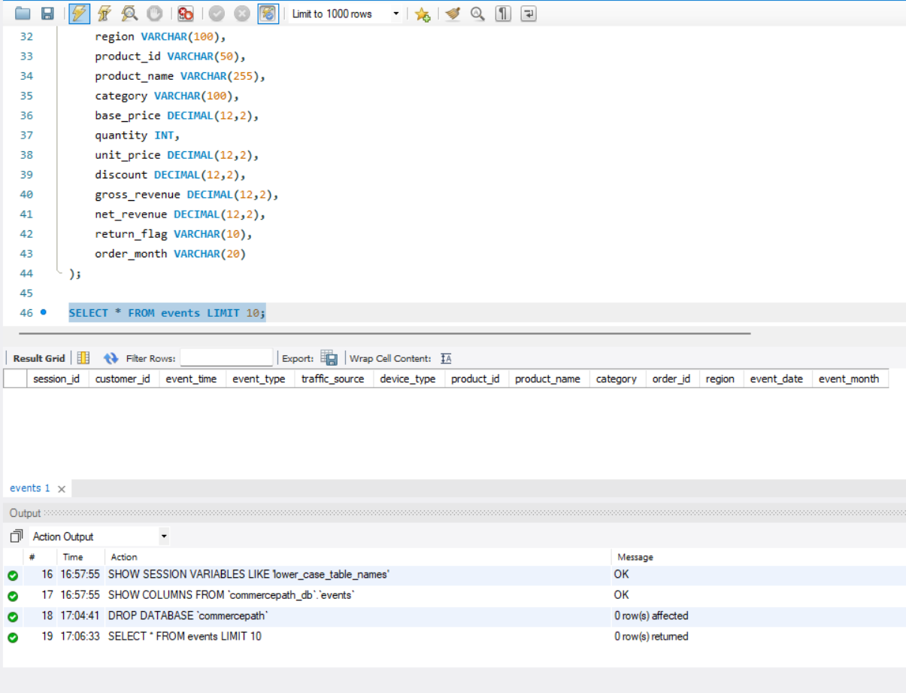

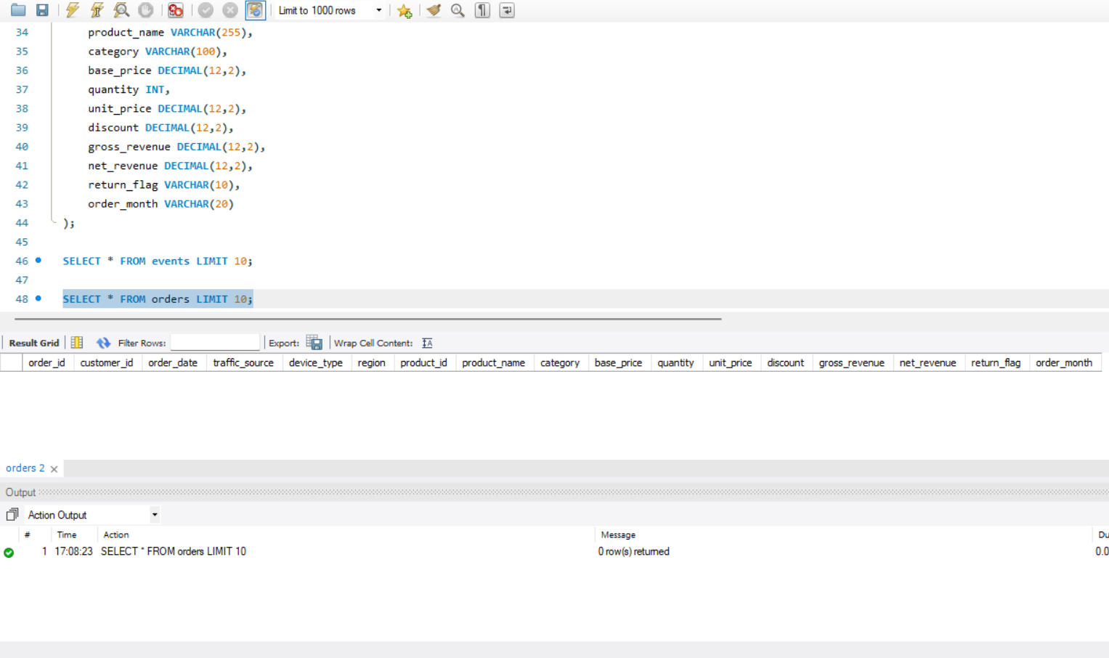
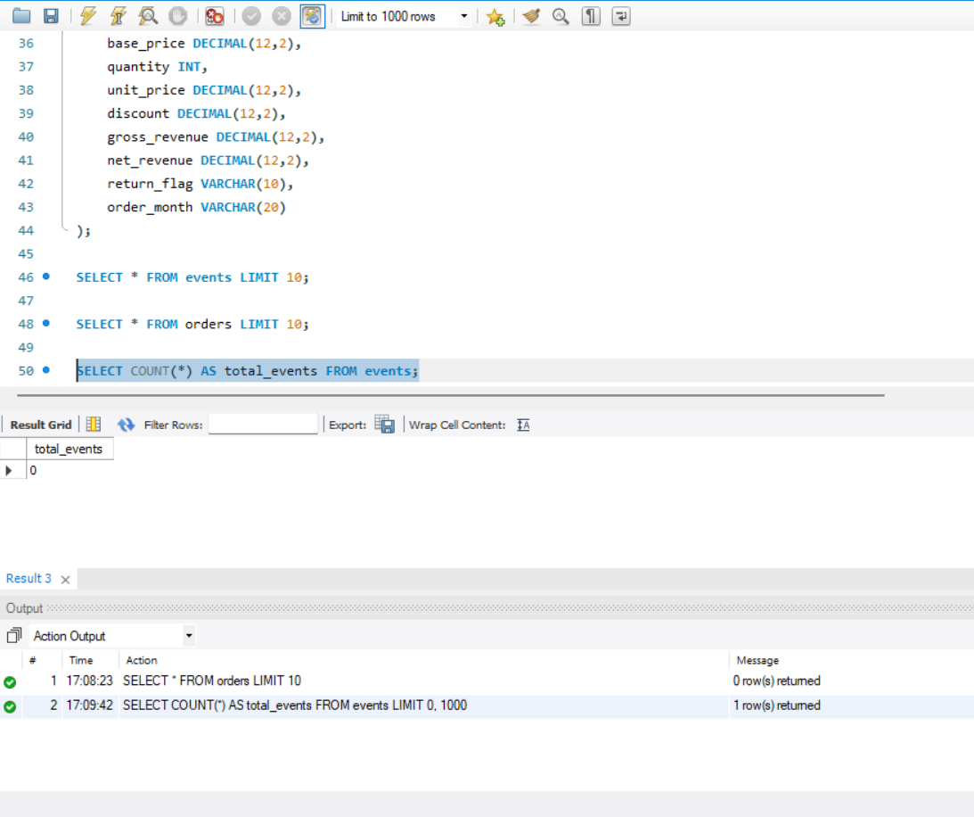

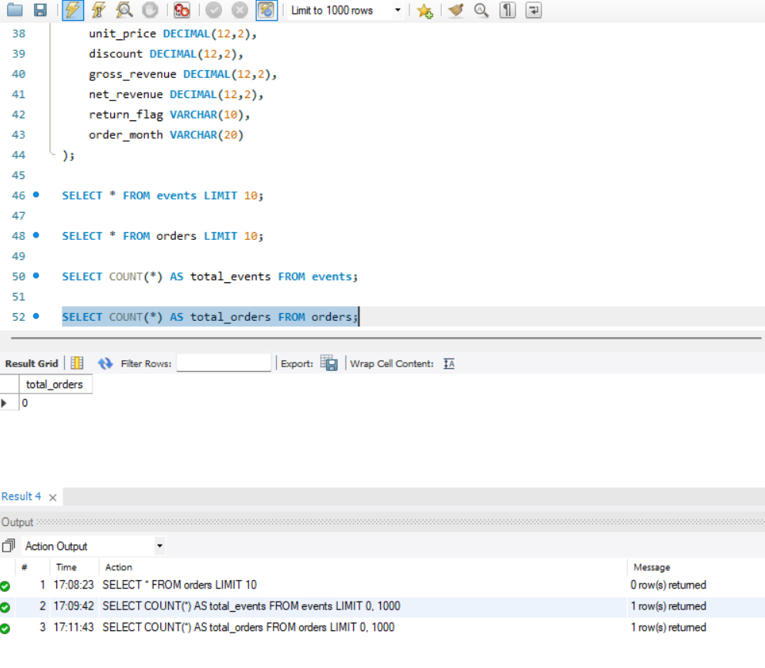

Q1. Funnel Stage Counts by Month.
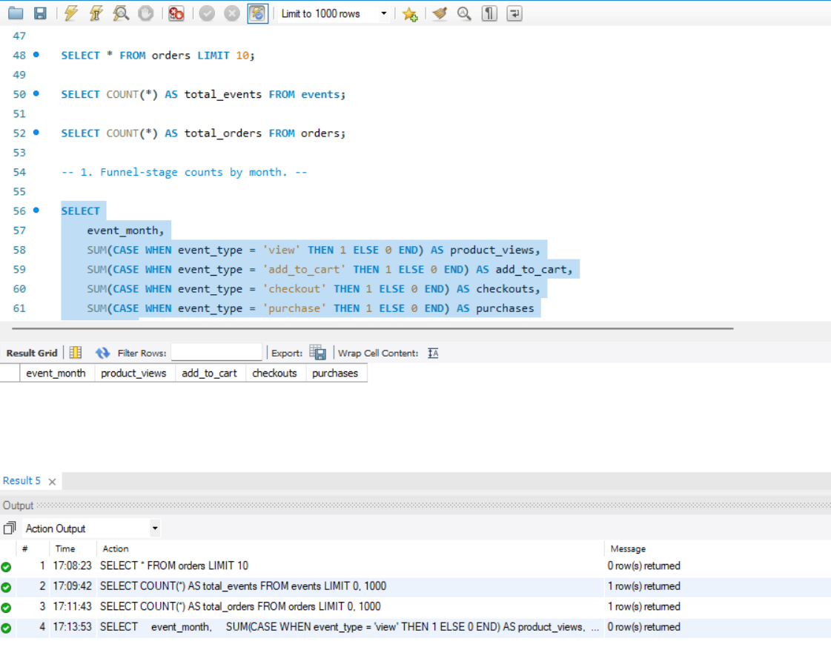

Q2. Conversion by Traffic Source.
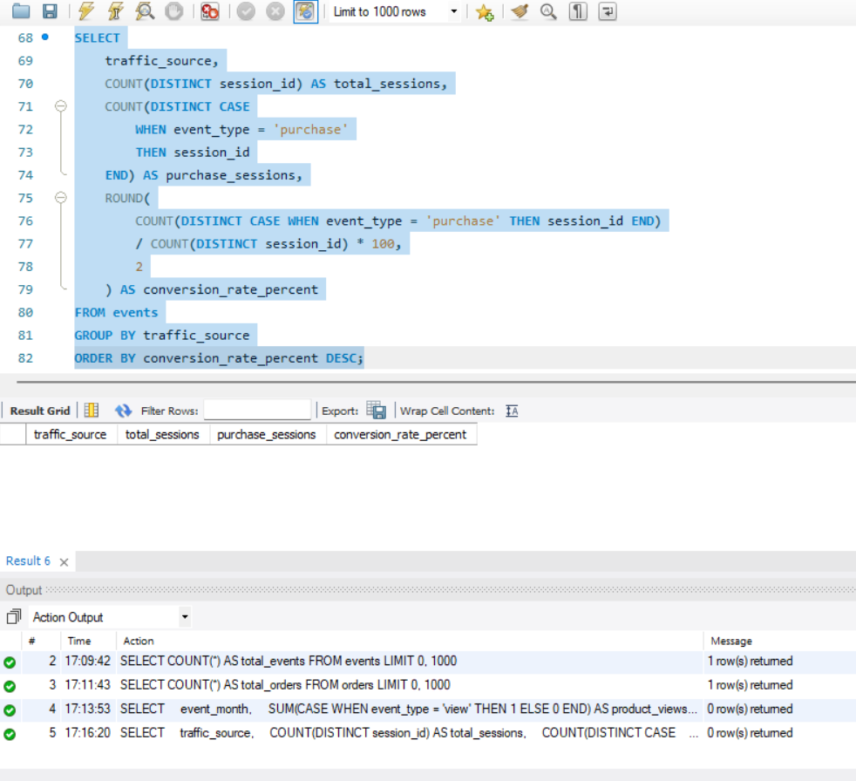

Q3. Device-Level Conversion Comparison.
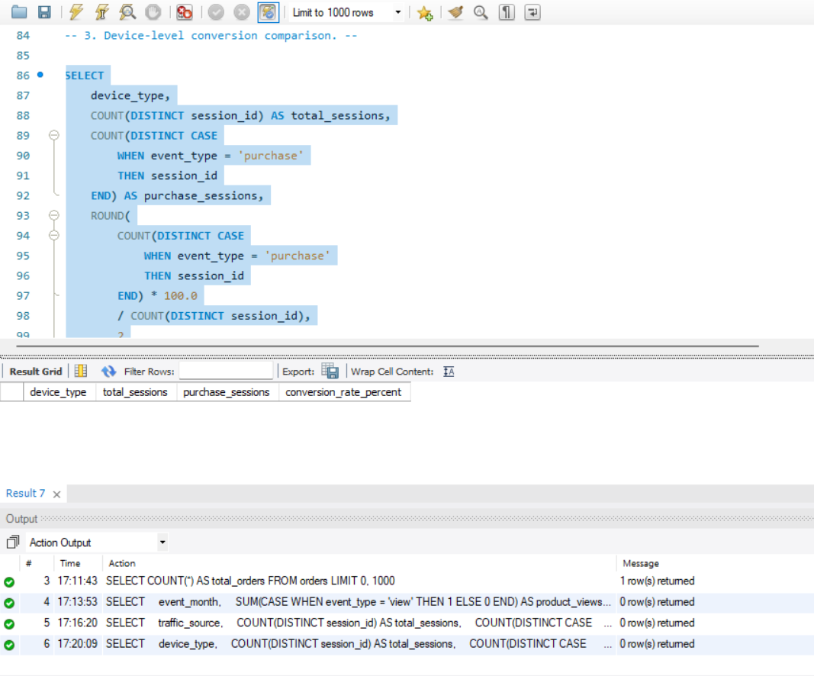

Q4. Category View-to-Purchase Conversion.
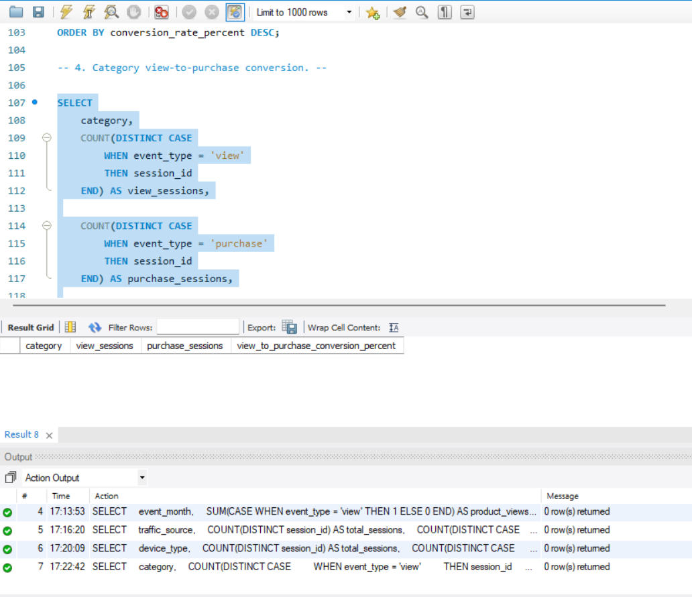

Q5. Average Order Value by Channel.
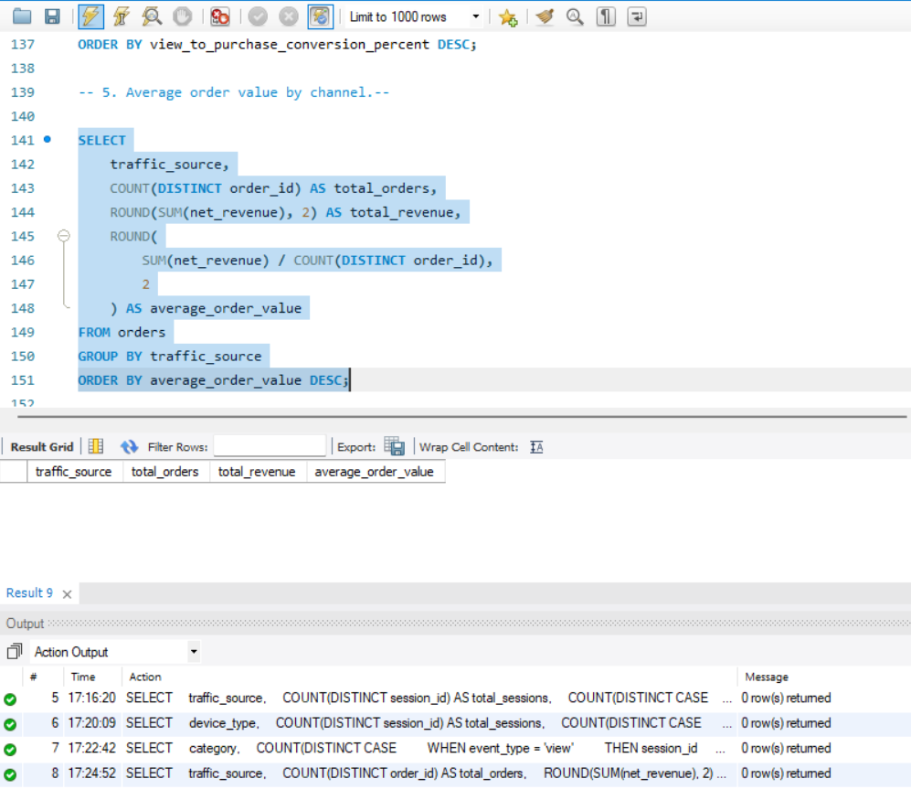

Q6. Repeat vs One-Time Customers.
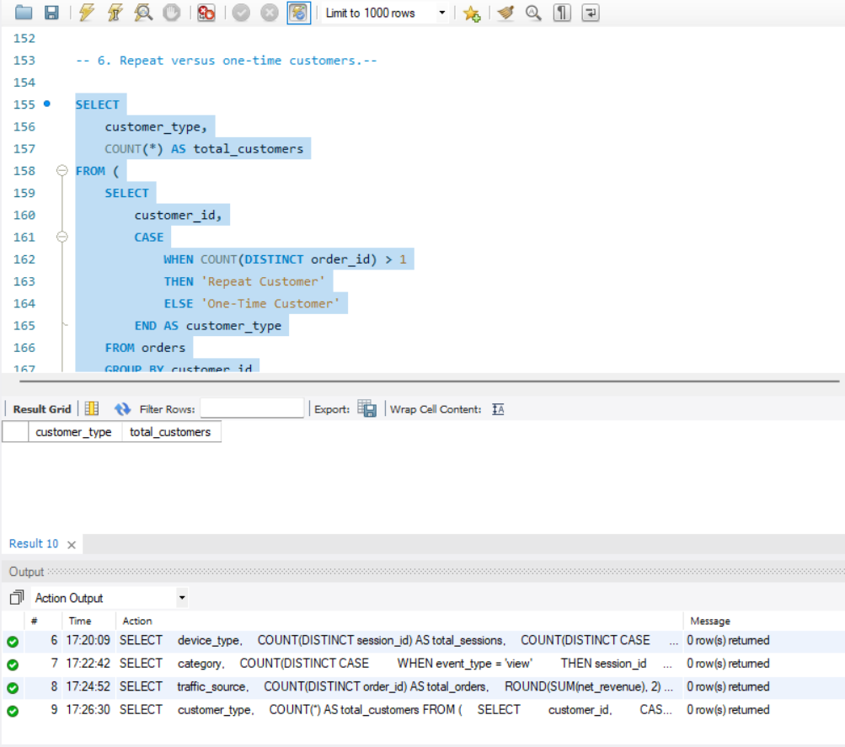

Q7. Top Products by Revenue and Returns.
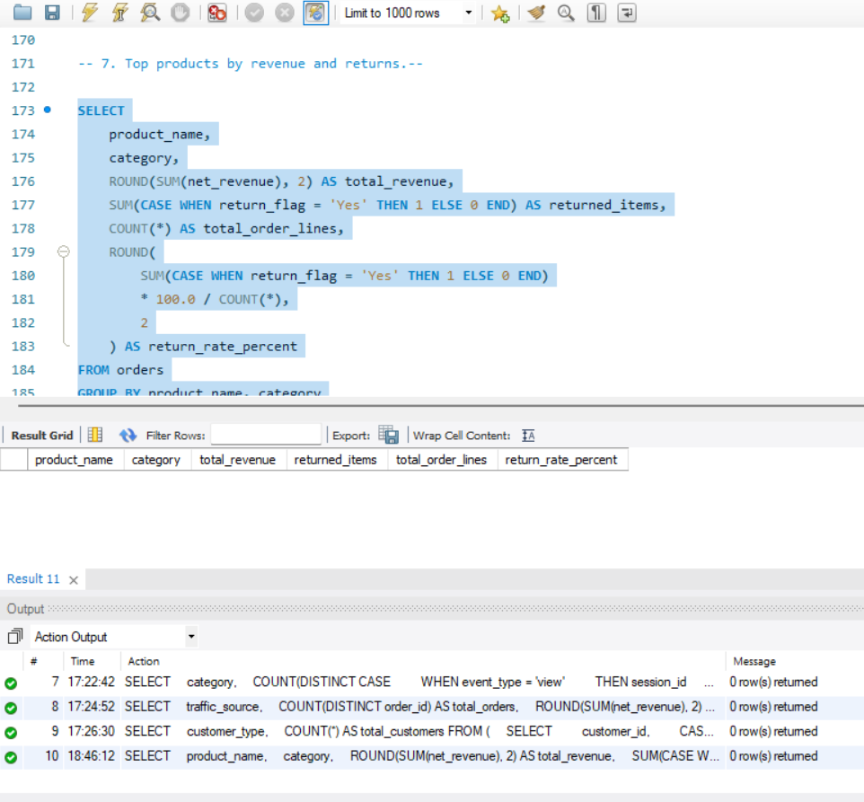

Q8. Cart Abandonment by Device.
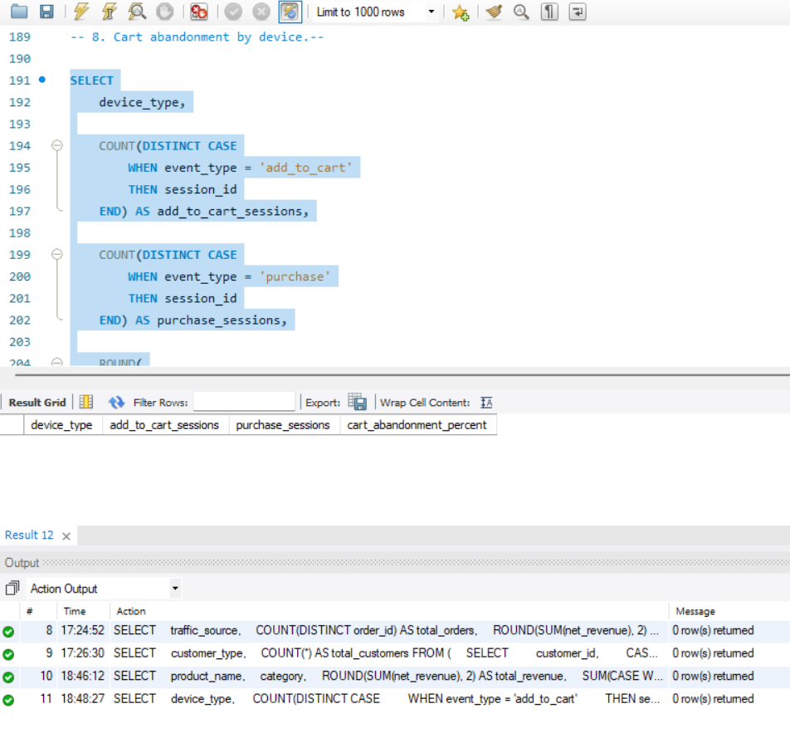

Q9. Customer Ranking by Lifetime Revenue.
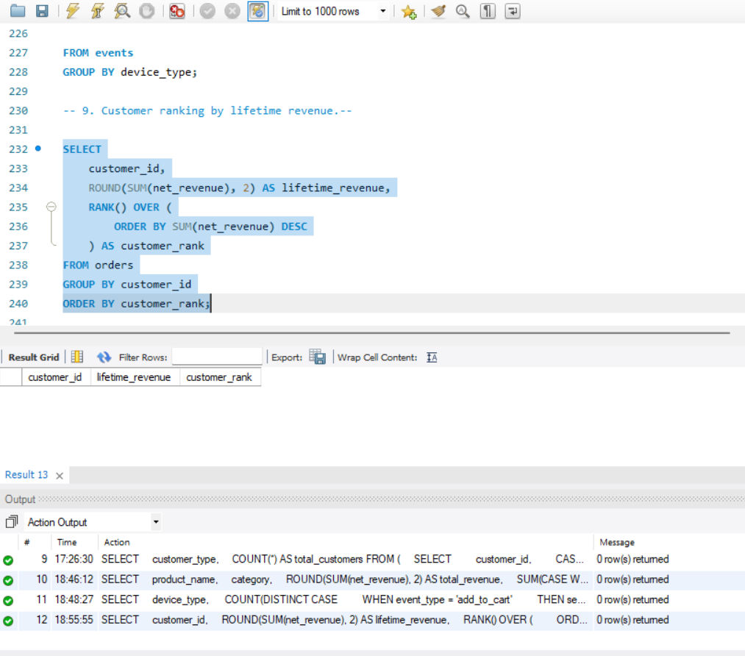

10. Monthly Running Revenue and Growth.
